**HOW TO INSTALL XAMPP SERVER IN UBUNTU**

First we have to download the XAMPP Server package from official website. So use the below command to download the package.

elinuxbook@ubuntu:~$ wget https://downloadsapachefriends.global.ssl.fastly.net/xampp-files/7.1.10/xampp-linux-x64-7.1.10-0-installer.run

--2017-10-24 08:29:10-- https://downloadsapachefriends.global.ssl.fastly.net/xampp-files/7.1.10/xampp-linux-x64-7.1.10-0-installer.run

Resolving downloadsapachefriends.global.ssl.fastly.net (downloadsapachefriends.global.ssl.fastly.net)... 151.101.0.249, 151.101.64.249, 151.101.128.249, ...

Connecting to downloadsapachefriends.global.ssl.fastly.net (downloadsapachefriends.global.ssl.fastly.net)|151.101.0.249|:443... connected.

HTTP request sent, awaiting response... 200 OK

Length: 137577889 (131M) [binary/octet-stream]

Saving to: ‘xampp-linux-x64-7.1.10-0-installer.run’

xampp-linux-x64-7.1.10-0-installer.run 100%[=====================================================================================>] 131.20M 91.6KB/s in 16m 0s

2017-10-24 08:45:11 (140 KB/s) - ‘xampp-linux-x64-7.1.10-0-installer.run’ saved [137577889/137577889]

Here I have download the XAMPP package in **.run** format. It’s an script file and downloaded without execute permission. Refer the output below.

elinuxbook@ubuntu:~$ ls -l xampp-linux-x64-7.1.10-0-installer.run **# Downloaded XAMPP Server Package**

-rw-rw-r-- 1 elinuxbook elinuxbook 137577889 Oct 19 14:43 xampp-linux-x64-7.1.10-0-installer.run

We cannot install this package without execute permission. Hence to give execute permission you can use the below command.

Now as you can see below the package has execute permission and it’s now ready for installation.

Use the below command to start the installation of XAMPP Server.

elinuxbook@ubuntu:~$ sudo ./xampp-linux-x64-7.1.10-0-installer.run **# Install the Package**

[sudo] password for elinuxbook:

We have to follow some GUI installation steps to install XAMPP Server package. So after execute the above command you will get the below screen in front of you. Here just click on **Next** to start the installation.

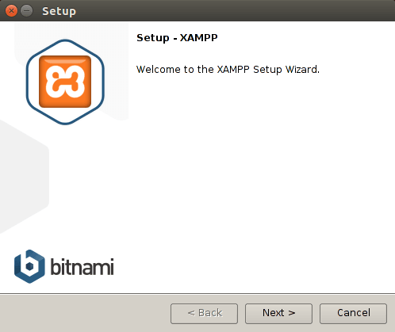

*INSTALL XAMPP SERVER*

Now select the compnents you want to include in installation. I would recommend go with default settings and click on **Next**.

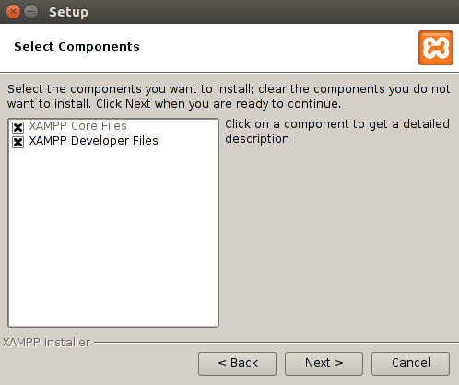

*SELECT XAMPP COMPNENTS*

Click on **Next** to continue the XAMPP Server installation.

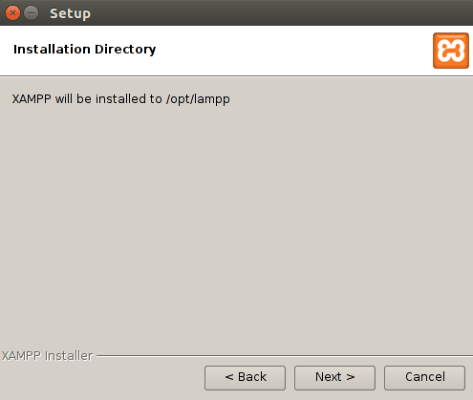

*XAMPP INSTALLATION DIRECTORY*

Click on **Next**.

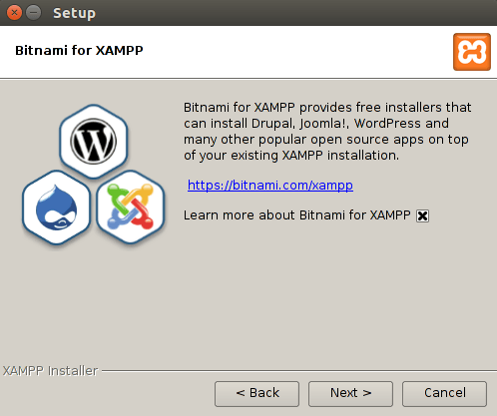

*CLICK ON NEXT*

Click on **Next** to install XAMPP Server package.

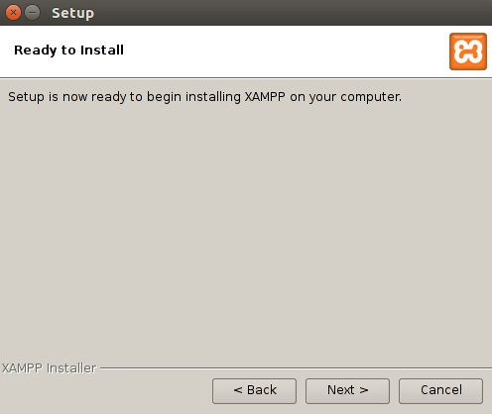

*START XAMPP INSTALLATION*

XAMPP Server installation is on progress.

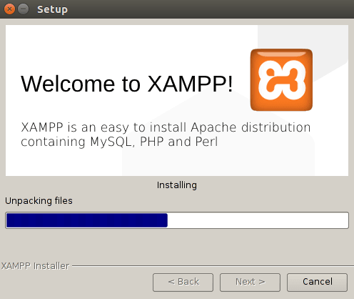

*INSTALLATION ON PROGRESS*

Click on **Finish** to complete the installation process.

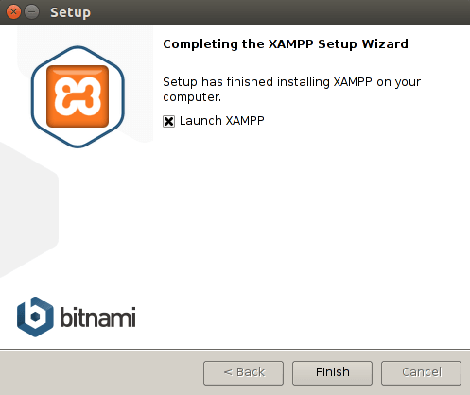

After installation you will get Welcome screen of XAMPP. Here we have two useful buttons. **Go To Application** button will take you to the dashboard of the XAMPP Server and **Open Application Folder** will take you to the XAMPP installation directory.